QUESTION 4

AIM:
To create a table named `COURSE` with columns `CourseNo`, `CourseDesc`, `CourseType`, `SemNo`, `HallNo`, and `FacNo` using DDL statement.

PROCEDURE:
1. Open the SQL database terminal/client.
2. Execute the `CREATE TABLE` command specifying table name `COURSE` and defined data types for each attribute.
3. Verify the creation using `DESC COURSE;`.

CODE / SQL QUERY:

CREATE TABLE COURSE (
CourseNo VARCHAR(3),
CourseDesc VARCHAR(14),
CourseType CHAR(1),
SemNo CHAR(1),
HallNo VARCHAR(4),
FacNo VARCHAR(4)
);

Output:

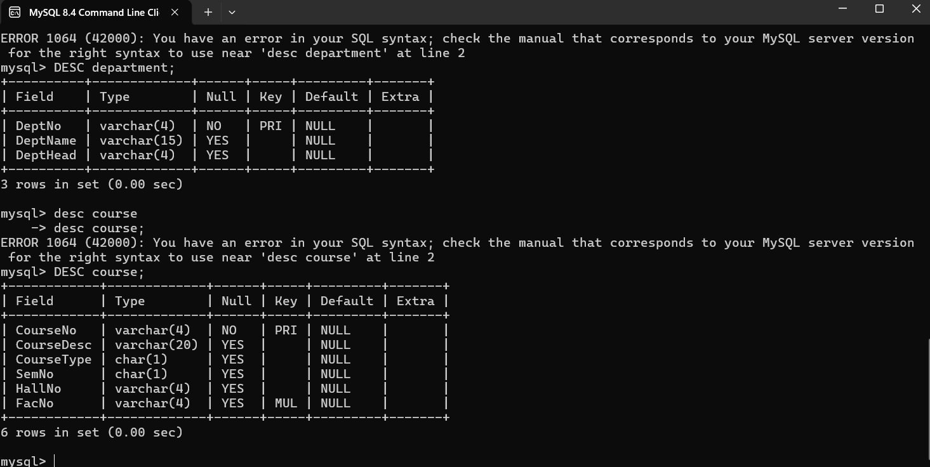

Result
The `COURSE` table has been created successfully with the required columns and data types.

